**Project Report**

**Abstraction:**

The Weather Forecasting Application (WFA) is a software system designed to provide users with accurate and up-to-date weather forecasts for specific locations. Leveraging data from various sources such as satellites, weather stations, and meteorological models, the WFA processes, analyzes, and generates forecasts for different weather parameters including temperature, humidity, precipitation, wind speed, and atmospheric pressure.

**Key Components:**

**1.Data Collection**

**2.Data Preprocessing:**

**3.Forecasting Models:**

**4.User Interface:**

**5.Visualization**

**Introduction: Weather Forecasting Application**

Weather forecasting has long been a critical aspect of human life, influencing decisions ranging from daily activities to large-scale operations in industries like agriculture, transportation, and disaster management. In today's interconnected world, the demand for accurate and timely weather information is higher than ever before. The Weather Forecasting Application (WFA) addresses this need by providing users with comprehensive and reliable weather forecasts tailored to their specific requirements.

**Purpose and Objectives:**

**1.Provide users with detailed forecasts for various weather parameters, including temperature, humidity, precipitation, wind speed, and atmospheric pressure.**

**2.Offer customizable forecast options to accommodate diverse user needs, such as long-term planning, outdoor activities, and event scheduling.**

**3.Enhance user safety and preparedness by issuing alerts and notifications for severe weather events and sudden changes in atmospheric conditions.**

**4.Support decision-making processes in sectors such as agriculture, transportation, tourism, and emergency response by delivering actionable weather insights.**

**5.Continuously improve the accuracy and reliability of forecasts through data analysis, model refinement, and user feedback mechanisms.**

**ER-Diagram:-**

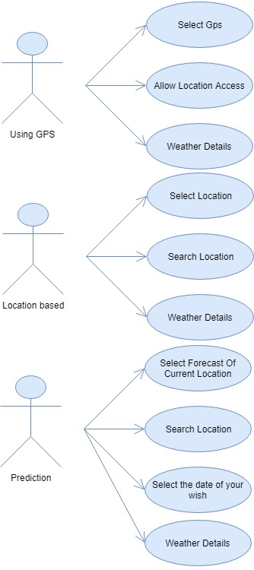

**Queries to create Database:**

**\*First we need to use any database which is present in the mysql**

**1.select * from weatherDatas;**

**2.select * from Forecast**

**3.select * from Location**

**4.select * from Sensor**

**5.select * from Alert**

**6.select * from User preferences**

**7.select * from Subscription**

**8.select * from Notification**

**=>All class java file codes:**

**weather_forecasting_application/**

**└── src/**

**├── main/**

**├── java/**

**└── com/**

**└── yourcompany/**

**└── weather/**

**├── model/**

**├── User.java**

**├── Location.java**

**├── Sensor.java**

**├── WeatherData.java**

**├── Forecast.java**

**├── Alert.java**

**├── Notification.java**

**└── Subscription.java**

**└── service/**

**├── WeatherDataService.java**

**├── ForecastService.java**

**├── AlertService.java**

**└── NotificationService.java**

**│ └── resources/**

**└── test/**

**└── java/**

**└── com/**

**└── yourcompany/**

**└── weather/**

**└── service/**

**├── WeatherDataServiceTest.java**

**├── ForecastServiceTest.java**

**├── AlertServiceTest.java**

**└── NotificationServiceTest.java**

**UML Diagram:** 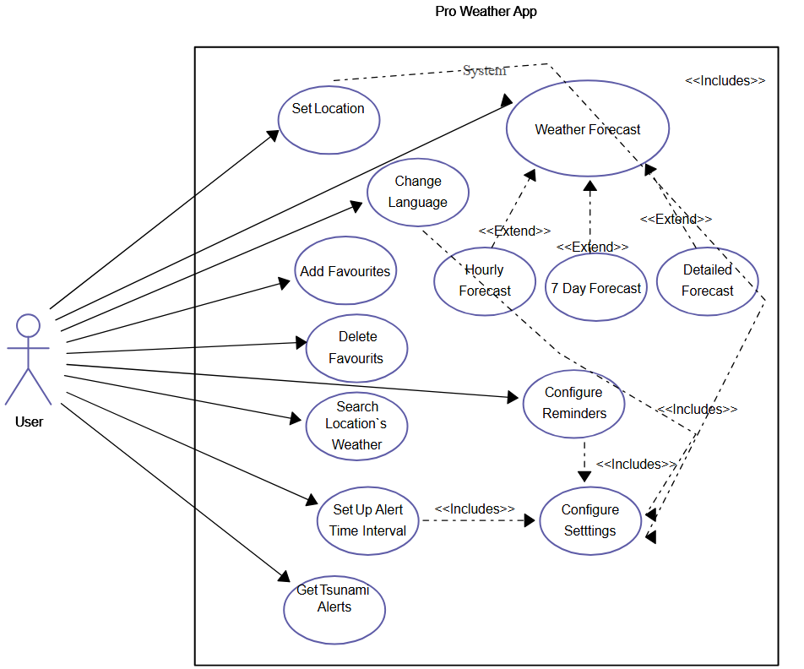

**Challenges list which we face while craeting the Database tables:**

**1.Faced difficulties while creating the tables its didn't accepted some attributes and values**

**2.** **Relationship in ER diagram**